**Lab 8 Activity 1 - Creating a Grocery Inventory Table**

**Objective:** Set up an inventory table with key columns for quantity, price, and total cost.

1. Open a new Excel workbook.

2. Create column headers: Item Name, Quantity, Price per Unit, and Total Price.

3. Enter at least five grocery items with sample values.

4. Save the workbook.

**____________________________________________________________________________________**

**Solutions:**

**Task 1:**

* Open Microsoft Excel
* 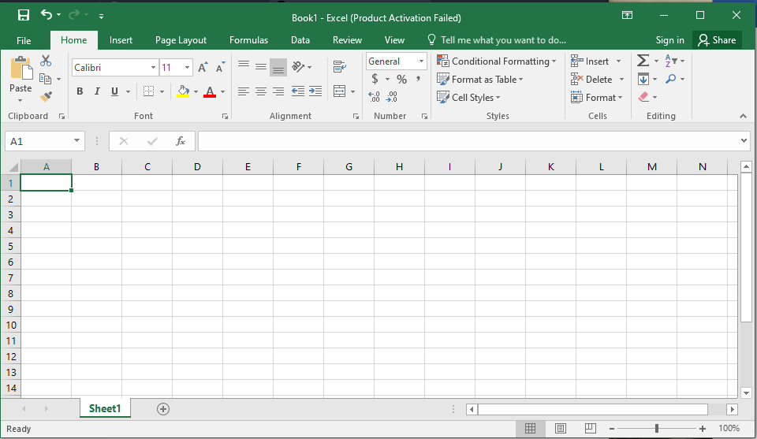Click on **Blank Workbook** to start with a new sheet.

**Task 2:**

1. Click on Cell A1 and type: Item Name
2. Click on Cell B1 and type: Quantity
3. Click on Cell C1 and type: Price per Unit
4. 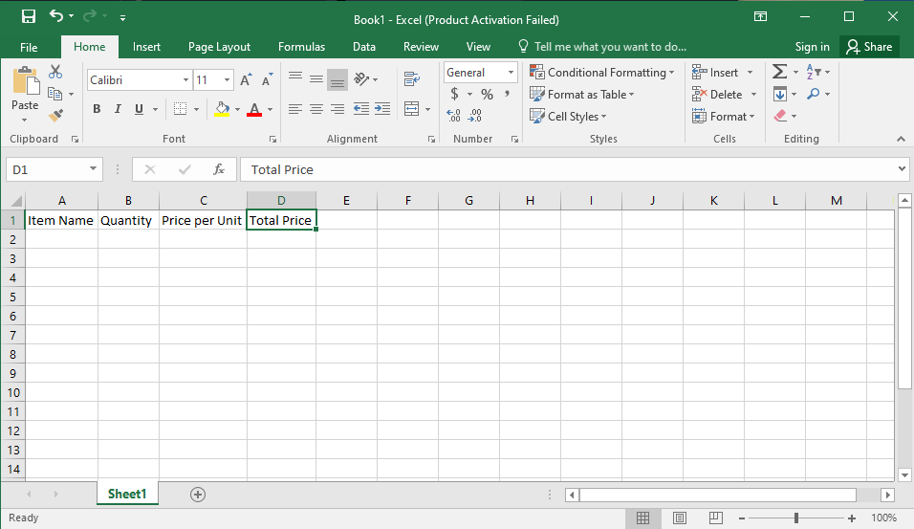Click on Cell D1 and type: Total Price

**Task 3:**

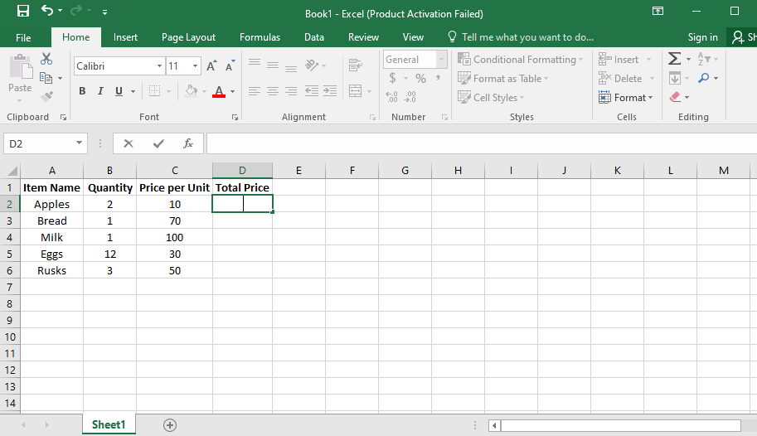

**Task 4:**

1. Click on File > Save As.
2. Choose a location
3. Enter a filename (e.g., Grocery List.xlsx).
4. Click Save.